May 3, 2022

Subject: Transition with new Contract Operator

Dear Peaks Mill Water District Customers:

During the month of May 2022, Peaks Mill Water District will be transitioning from its longtime operator, Dale Gatewood of Gatewood Water Services to our new contract operator, Jeff Lee of C&L Consulting. We will also be hiring new staff to assist with operations and maintenance of the water district.

Jeff Lee, of C&L Consulting, will serve as our licensed operator. His phone number for after-hours emergencies is 859-619-9835. During normal business hours (Monday to Friday: 8:30 AM to 3:30 PM), our customer service phone line is 502-227-5740.

During this transition, our new operator will be learning the water system, and we expect there will be times when service and response times may be delayed. We ask for your patience during this transition, as we train our new staff in the daily activities of managing the District. Our office staff will not change.

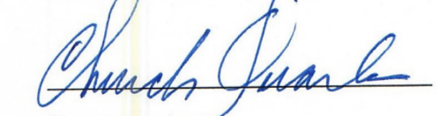
Sincerely,

Church Quarles
Chairman
Peaks Mill Water District

Cc: Nancy Sherrow, Peaks Mill Water District
Jeff Lee, C&L Consulting
Greg Heitzman, BlueWater Kentucky

